✅ What is Azure Kubernetes Service (AKS)?
Azure Kubernetes Service (AKS) is a managed Kubernetes offering from Microsoft Azure that simplifies the deployment, management, and operations of Kubernetes clusters. It abstracts away much of the complexity of infrastructure management, enabling developers to focus on building and scaling containerized applications.
🚀 Key Benefits:
- Fully managed control plane (no need to manage master nodes)
- Integrated monitoring, scaling, and security
- Azure-native integrations (Azure DevOps, ACR, NSGs, Azure Monitor, etc.)
- Supports both Linux and Windows containers
- Cost-effective (pay only for agent nodes)
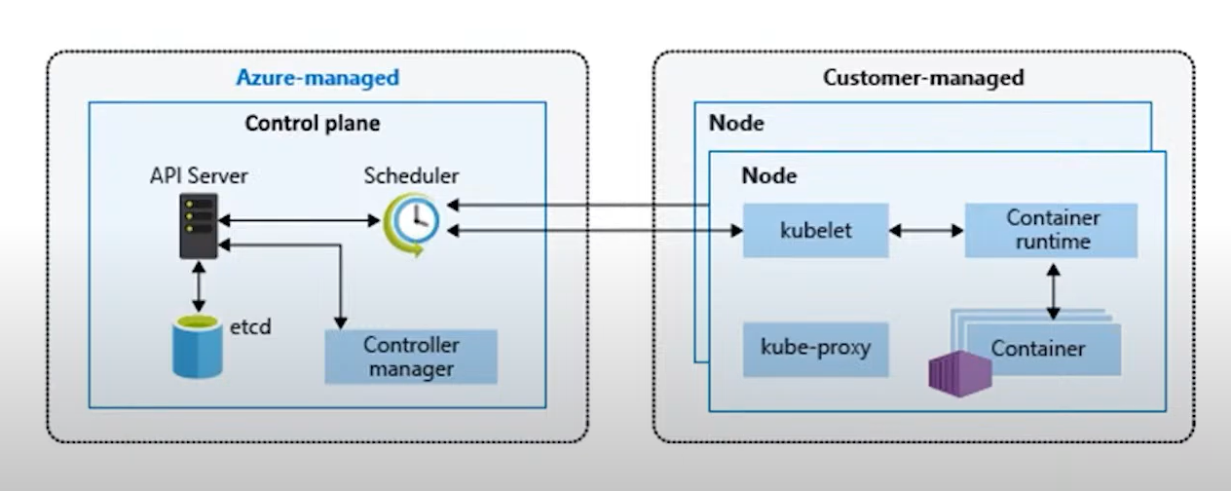

🔷 1. Azure-managed (Control Plane)
Microsoft fully manages this section. You don’t need to configure or pay directly for these components in AKS.
✅ a. API Server
- It is the front door to the Kubernetes control plane.
- All interactions (kubectl, dashboard, automation tools, etc.) go through the API Server.
- It validates and processes REST requests, updates etcd, and communicates with other components.
- The API server in AKS is the entry point for all cluster management operations, not for application traffic.
- When you run kubectl get pods or az aks get-credentials, your client talks to the API server at this public endpoint IP.
Example: When you apply a YAML file, it first goes to the API server.

✅ b. etcd
- A highly available key-value store used as the database for all Kubernetes cluster data.
- Stores configuration, secrets, state of all Kubernetes objects (pods, deployments, services, etc.).
- Managed securely by Azure, with backup and encryption.

✅ c. Scheduler
- Decides where (which node) a new pod should run.
- Considers:
  - Resource availability (CPU, memory)
  - Node affinity rules
  - Taints and tolerations
  - Pod topology
- Doesn't run the pod — just assigns it to the most appropriate node.

✅ d. Controller Manager
- Watches the cluster’s state and ensures it matches the desired state (what’s defined in your manifests).
- Includes:
  - ReplicaSet controller (maintains number of pod replicas)
  - Node controller (monitors node health)
  - Deployment controller
  - Service account controller
If a pod crashes, the controller manager ensures a new one is scheduled.

🔶 2. Customer-managed (Node Components)
You manage the worker nodes and everything that runs on them (applications, configurations, monitoring, etc.).
Each Node (VM in Azure) has:
✅ a. kubelet
- Agent running on each node.
- Gets instructions from the control plane (API Server) and ensures containers are running as specified.
- Talks to the container runtime (like containerd) to start/stop containers.

✅ b. kube-proxy
- Handles network routing for services and pods.
- Maintains rules for:
  - Pod-to-pod communication
  - Load balancing for services (ClusterIP, NodePort, etc.)
- Supports both iptables and IPVS modes.

✅ c. Container Runtime
- Software responsible for running containers.
- Common runtimes: containerd, Docker (deprecated in AKS), or CRI-O.
- Interacts with the OS to start and manage containers.

🔹 Cluster
✔ The highest-level component in AKS.
✔ Contains multiple nodes (VMs) for running applications.
✔ Managed by the Azure control plane (automatically handled by Azure).
🔹 Nodes
✔ Nodes are virtual machines (VMs) in an AKS cluster.
✔ They run workloads and host pods.
✔ Can be Linux or Windows-based.
✔ Includes Kubelet (to manage pods), container runtime (like Docker), and networking components.
✔ Node Pool: A group of nodes with the same configuration (e.g., Linux pool, Windows pool).
🔹 Pods
✔ The smallest deployable unit in Kubernetes.
✔ A pod runs one or more containers.
✔ Pods share network and storage within the same node.
Each pods have their own IP address
🔹 Containers
✔ Containers run inside pods.
✔ Containers are lightweight, portable, and use images (like Docker images).
✔ Each container runs a specific application or microservice.
- The actual application workloads running inside pods.
- Each container is isolated, runs its own process, and uses the resources defined in the manifest.
Example: A web app container, a database container, etc.

🔁 How It All Connects:
- You deploy a manifest → API Server receives it.
- API Server stores it in etcd, sends it to the Scheduler.
- Scheduler decides the best node → passes to Controller Manager.
- Kubelet on that node receives the pod spec → uses Container Runtime to run the container.
- Kube-proxy manages networking so the pod can communicate.

✅ Summary Table:
Component | Managed By | Role
API Server | Azure | Front-end for all commands
Etcd | Azure | Cluster data store
Scheduler | Azure | Assigns pods to nodes
Controller Manager | Azure | Maintains desired state
Kubelet | You (Node) | Enforces pod state
Kube-proxy | You (Node) | Manages pod/service networking
Container Runtime | You (Node) | Starts and stops containers
Containers | You (Pod level) | Run the actual apps

1️⃣ AKS Overview
✔ AKS is a managed Kubernetes service in Azure.
✔ It helps deploy, manage, and scale containerized applications.
✔ Removes the complexity of setting up and managing Kubernetes manually.
2️⃣ AKS Architecture

3️⃣ AKS Deployment Steps
✔ Step 1: Create an Azure Kubernetes Service (AKS) Cluster
✔ Step 2: Configure node pools based on workload requirements
✔ Step 3: Deploy applications as pods
✔ Step 4: Expose services using Load Balancers or Ingress
✔ Step 5: Set up monitoring and logging (Azure Monitor, Log Analytics)

4️⃣ AKS Networking
✔ Azure CNI (assigns a unique IP to each pod from VNET)
✔ Kubenet (uses NAT for pod networking, fewer IPs needed)
✔ Load Balancers, Ingress Controllers (to expose applications)
While creating the AKS cluster, we need to define the network plugin — either Kubenet or Azure CNI — and it cannot be changed later.
In Kubenet, only the nodes get IPs from the VNet. The pods get private IPs from an internal, non-VNet range, and NAT is used for outbound communication and cross-node pod-to-pod traffic.
In Azure CNI, both nodes and pods get IPs directly from the Azure VNet subnet, allowing native communication between any pods or nodes without NAT
🔁 AKS Service Types (Manage Traffic Routing)
Service Type | Purpose | Internet Access
ClusterIP | Default; internal-only communication between pods | ❌
NodePort | Exposes service on a static port on each node | ✅ (via node IP)
LoadBalancer | Creates Azure Public Load Balancer | ✅
ExternalName | Maps service to external DNS name | ✅
Ingress (Controller) | Not a service itself; routes HTTP(S) based on host/path | ✅ (used with LoadBalancer)

5️⃣ AKS Scaling & Management
✔ Horizontal Pod Autoscaler (HPA): Auto-scales the number of pods based on CPU/memory usage.
✔ Cluster Autoscaler: Automatically adds/removes nodes based on workload.
✔ Manual Scaling: Nodes and pods can be scaled manually using kubectl scale.

6️⃣ Security & Access Control
✔ Azure Active Directory (AAD) Integration for authentication.
✔ Role-Based Access Control (RBAC) to manage user permissions.
✔ Network Policies & NSGs for traffic control.

7️⃣ AKS Monitoring & Troubleshooting
✔ Azure Monitor & Log Analytics for tracking cluster health.
✔ kubectl logs for checking pod logs.
✔ kubectl describe pod <pod-name> for troubleshooting failed pods.

8️⃣ AKS Storage Options
✔ Azure Disks: Persistent storage for single pods.
✔ Azure Files: Shared storage across multiple pods.
✔ EmptyDir, ConfigMaps, Secrets for lightweight storage needs.

9️⃣ High Availability & Disaster Recovery
✔ Multiple node pools for resilience.
✔ Availability Zones for redundancy.
✔ Backup & Restore with Velero or Azure Backup.

🔷 What is Ingress?
Ingress is a Kubernetes object that lets you expose your internal services (Pods) to the outside world — typically via HTTP or HTTPS — using a single IP and domain.
It's like a traffic controller at the entrance of your cluster.

🧱 Without Ingress
If you want to expose 3 apps to the internet:
- You create 3 services of type LoadBalancer
- Azure assigns 3 public IPs (one for each service)
- Not efficient and more costly

✅ With Ingress
- You create one public IP using a LoadBalancer + Ingress Controller
- Define Ingress rules for your apps (based on URL paths or hostnames)
- All traffic goes through this one point, then routed to correct app

AKS
├── Cluster
│ ├── Nodes (VMs)
│ │ ├── Pods
│ │ │ ├── Containers (Apps)
│ │ │ ├── Shared Storage & Network

This manifest defines: YAML or JSON
- A Deployment: to manage your app container with 2 replicas.
- A Service: to expose it to the internet using a LoadBalancer.

✅ Common Kubernetes Manifest File Types
Resource | Kind | Purpose
Pod | Pod | Runs one or more containers
Deployment | Deployment | Manages replicas and rolling updates
Service | Service | Exposes app inside or outside cluster
ConfigMap | ConfigMap | Stores non-sensitive config data
Secret | Secret | Stores sensitive info like passwords
Ingress | Ingress | Manages external access via HTTP/HTTPS
Persistent Volume | PersistentVolumeClaim | Handles disk storage for pods

For Deploying Docker images from ACR into AKS Cluster
The following command allows you to authorize an existing ACR in your subscription and configures the appropriate ACRPull role for the managed identity.
az aks update -n myAKSCluster -g myResourceGroup --attach-acr myacrrepo31
To Detach ACR from AKS use below command
az aks update -n myAKSCluster -g myResourceGroup --detach-acr myacrrepo31

apiVersion: v1 # API version of the object
kind: Pod/Service/Deployment # Type of Kubernetes object
metadata:
name: my-app # Name of the object
labels:
app: demo
spec:
containers: # For pod/deployment
- name: nginx
image: nginx:1.21
ports:
- containerPort: 80

✅ Short Answer:
🔸 The Kubelet monitors node and pod health locally, and
🔸 The Kube Controller Manager and Scheduler react to that information,
but the Kube Controller Manager itself does not directly check node/pod health.
It relies on reports from the Kubelet and the API server.

🔷 Key Components and Their Responsibilities
Component | Responsibility | Role in Health Checking
Kubelet (on each node) | Agent running on each node | Reports node and pod health to API server
Kube Controller Manager | Runs various controllers (Node, ReplicaSet, etc.) | Uses health reports from the Kubelet (via API server) to make decisions (e.g., mark node NotReady, recreate pods)
Kube Scheduler | Assigns pods to nodes | Uses node health info to avoid scheduling to bad nodes
API Server | Central communication hub | Collects health reports from all components
Kube Proxy | Manages network rules | Not involved in health checks

🔹 Node Health Monitoring
- The Kubelet sends heartbeat status every few seconds to the API server.
- The Node Controller (part of the Kube Controller Manager) watches these heartbeats:
  - If heartbeats stop (e.g., for 40 seconds by default), it marks the node as NotReady.
  - If no response for a longer time (e.g., 5 minutes), the node may be evicted, and pods rescheduled.

🔹 Pod Health Monitoring
- The Kubelet checks pod container health using:
  - Liveness probes – is the container still alive?
  - Readiness probes – is it ready to serve traffic?
- If a container fails its liveness probe, the Kubelet restarts it.
- If a pod is on a failed node, the ReplicaSet Controller (via the Controller Manager) may spin up new pods elsewhere.

🔸 So to directly answer:
Does the Controller Manager check node/pod health?
- ❌ It does not perform direct health checks.
- ✅ It responds to health updates sent by Kubelet to the API server.
- ✅ It uses that data to manage node states, reschedule pods, maintain desired state.

📌 TL;DR
Component | Does it check health directly? | What does it do with health info?
Kubelet | ✅ Yes | Monitors pod & node health, sends to API server
Controller Manager | ❌ No | Watches API server & takes action (e.g., mark NotReady, recreate pods)
Scheduler | ❌ No | Avoids scheduling pods on unhealthy nodes

Let me know if you’d like to see the exact flow or how to observe this in your AKS cluster!
Ask ChatGPT

